🔥 Day 18 — DNS Behavior + Hidden Layer (/etc/hosts)
Today’s goal:
👉 Understand how DNS resolution actually happens step-by-step
👉 And how to override DNS manually (very powerful skill)

1️⃣ Check Resolution Order (Important)
Run:
cat /etc/nsswitch.conf
Look for:
hosts: files dns

💡 Meaning:
files → /etc/hosts
dns → DNS server
👉 System checks:
- /etc/hosts first
- Then DNS server

2️⃣ Test Normal DNS
Run:
ping google.com
✔ Works
Now check:
nslookup google.com

3️⃣ 🔥 Override DNS (Very Important)
Edit:
sudo vi /etc/hosts
Add this line:
1.2.3.4 google.com

4️⃣ Test Again
ping google.com

What happens?
❗ It will try:
google.com → 1.2.3.4
👉 NOT real Google IP

Verify:
ping google.com
You’ll see:
PING google.com (1.2.3.4)

5️⃣ Understand What Just Happened
You forced system to:
Ignore DNS
Use /etc/hosts instead

6️⃣ Remove Entry (Fix)
Edit:
sudo vi /etc/hosts
Delete:
1.2.3.4 google.com

Test again:
ping google.com
✔ Back to normal

7️⃣ 🔥 Real Use Case (VERY IMPORTANT)
This is used in real world for:
- Testing websites before DNS goes live
- Blocking domains
- Debugging wrong DNS behavior

8️⃣ Mini Debug Scenario
Add wrong entry again:
1.2.3.4 google.com
Now run:
nslookup google.com
👉 It still shows correct IP
BUT:
ping google.com
👉 Uses wrong IP

💡 KEY LEARNING
nslookup → DNS server
ping → system resolver (/etc/hosts first)

🧠 What You Must Write Today
Resolution Order
/etc/hosts → DNS server

Key Difference
nslookup ignores /etc/hosts
ping follows /etc/hosts

Real Insight
System resolution and DNS resolution are not always same.

✅ Expected Output (Day 18)
You should have:
✔ Checked nsswitch.conf
✔ Modified /etc/hosts
✔ Forced wrong DNS resolution
✔ Observed difference between ping & nslookup
✔ Restored system

Step 1: Check the "Rules of the Road"
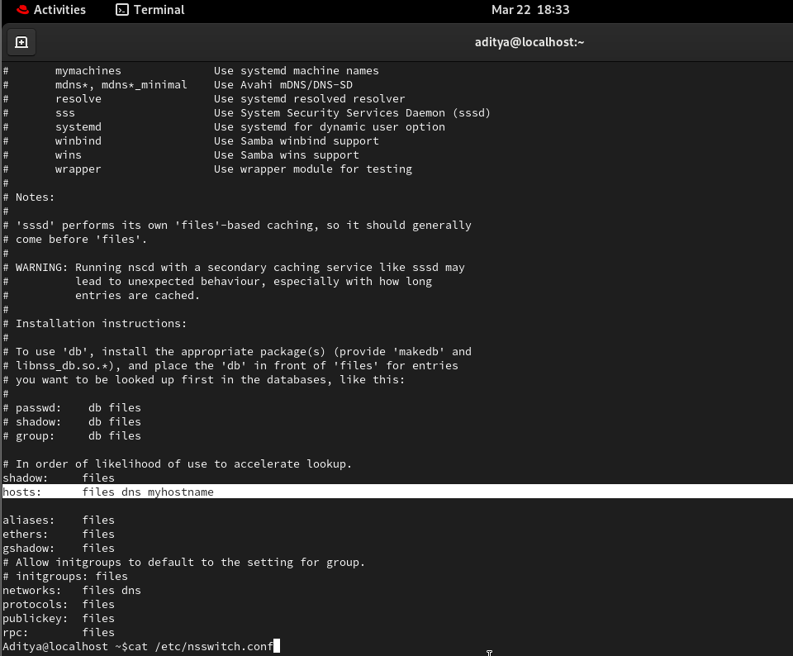
Step 2: Test the "Normal" State
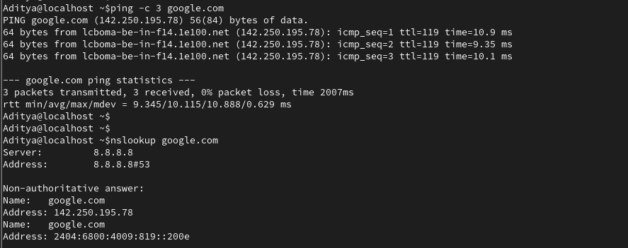
Step 3: Perform the "Hijack" (Edit /etc/hosts)
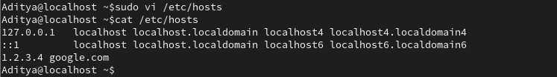
Step 4: Observe the Conflict
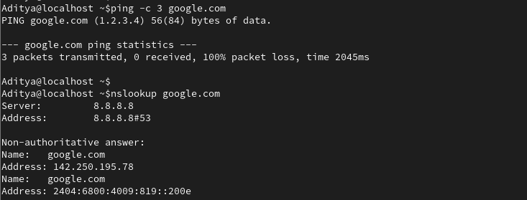
Step 5: Clean Up (The "Fix")
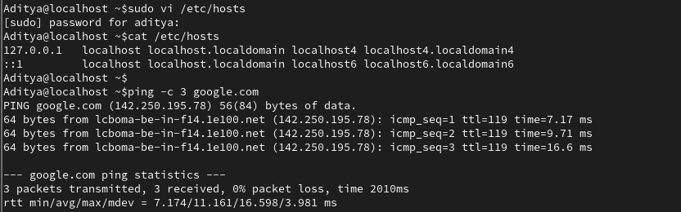

📓 Day 18: DNS Behavior & The Hidden Layer
1. The Resolution Hierarchy
The system follows a strict order defined in /etc/nsswitch.conf.
- The Config: hosts: files dns
- The Law:
  - files: Check /etc/hosts (Local Address Book) FIRST.
  - dns: Check Remote DNS Servers (Global Phone Book) SECOND.
2. The Critical Distinction (The "Aha!" Moment)
Not all network tools behave the same. This is vital for troubleshooting:
- System Resolver Tools (ping, curl, Browsers): These follow the hierarchy. If you change /etc/hosts, these tools change behavior.
- DNS Specialist Tools (nslookup, dig, host): These bypass /etc/hosts and talk directly to the DNS server.
  - Observation: Even if you lie to the system in /etc/hosts, nslookup will still tell you the truth from the internet.
3. Lab Results: The "Google Hijack"
- Step: Added 1.2.3.4 google.com to /etc/hosts.
- Result (Ping): google.com resolved to 1.2.3.4 (Internal file priority).
- Result (Nslookup): google.com resolved to 142.250.x.x (Direct DNS query).
- Step: Deleted the entry to restore the system.
4. Real-World Power Moves
- Testing: Map a domain to a development server before the site goes live.
- Blocking: Map a distracting domain (e.g., 0.0.0.0 facebook.com) to block it system-wide.
- Speed: Frequently used internal IPs can be added to /etc/hosts to avoid DNS latency.

💡 Key Takeaway: The /etc/hosts file is the ultimate authority for your local machine. If a website isn't loading but nslookup says it's fine, always check the "Hidden Layer" first.

